**JIRA SOFTWARE**

|  |  |
| --- | --- |
| Date | 29 October 2022 |
| Team ID | PNT2022TMID50980 |
| Project Name | Project **-** Skill and Job Recommender |

TEAM MEMBERS:

1. Annapoorani T
2. Usha T
3. Femina begam R
4. Anjali P

**ROAD MAP**

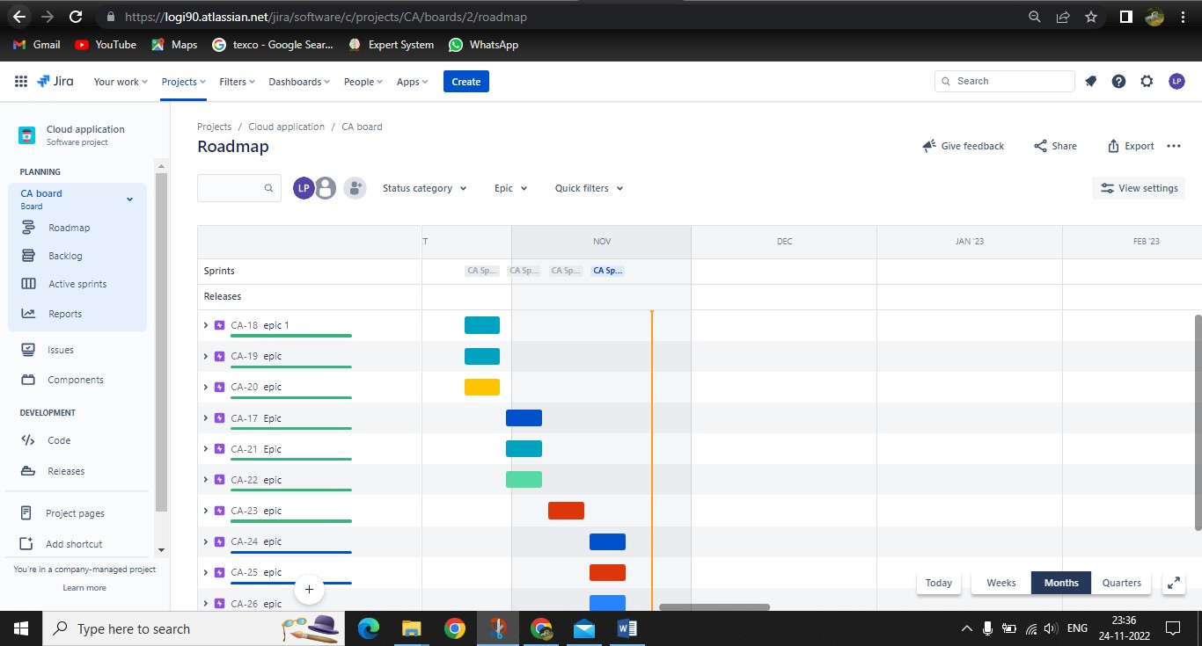

**BACK LOG**

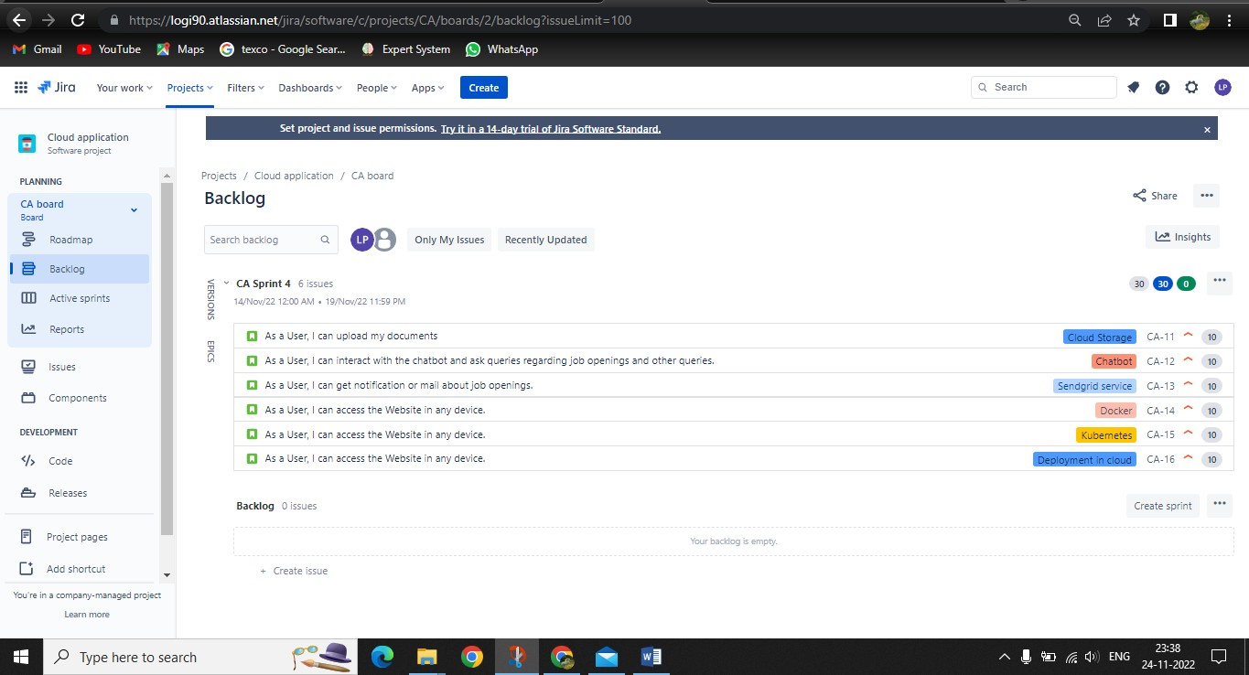

**CA BOARD**

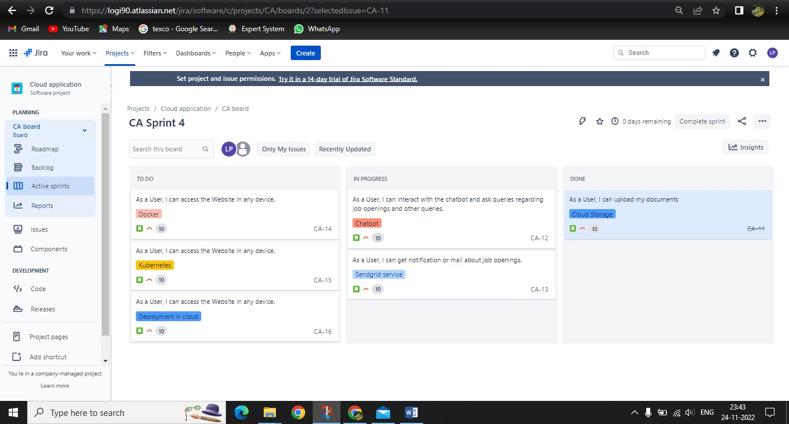



**JIRA SOFTWARE LINK**

https://logi90.atlassian.net/jira/software/c/projects/CA/boards/2?selectedIssue=C A-11